**DSGN1 Final Project**

**Oh, The Iron-y**



Taherah Abbas, Tyler Chau, Dana Chung, Isabel Li, Stephen Luxford, and Alison Pin

**Introduction:**

The item that our design team decided to tackle in redesigning is the common, household iron. Specifically, we decided to redesign a particularly badly designed Black & Decker branded iron owned by one of our team members. One would think that something as mundane as an iron that people use in their day to day lives when doing their laundry would be simple to use. However, the iron we tested from Black & Decker was strikingly hard to use on initial impression by all of our team members due to its confusing signifiers and affordances. This in turn inspired us to attempt to design a better iron in general that may become the industry standard for irons. In terms of error analysis and data collection, we shall be focusing on user data from the poorly designed Black & Decker iron. While our team was aware that an alternative product to the iron exists in the form of steamers, we have decided to focus purely on the category of irons as a form of getting wrinkles out of clothing. In order to design a better iron in the most efficient and effective manner possible, our design team utilized the **Double Diamond Design Process,** a process defined by 2 converging and 2 diverging stages: discover, define, develop, and deliver. By working collaboratively in this divergent and convergent methodology of design, we were able to create the most innovative iteration of the common iron to date while adhering to the time and budget constraints that designers face in everyday design undertakings. 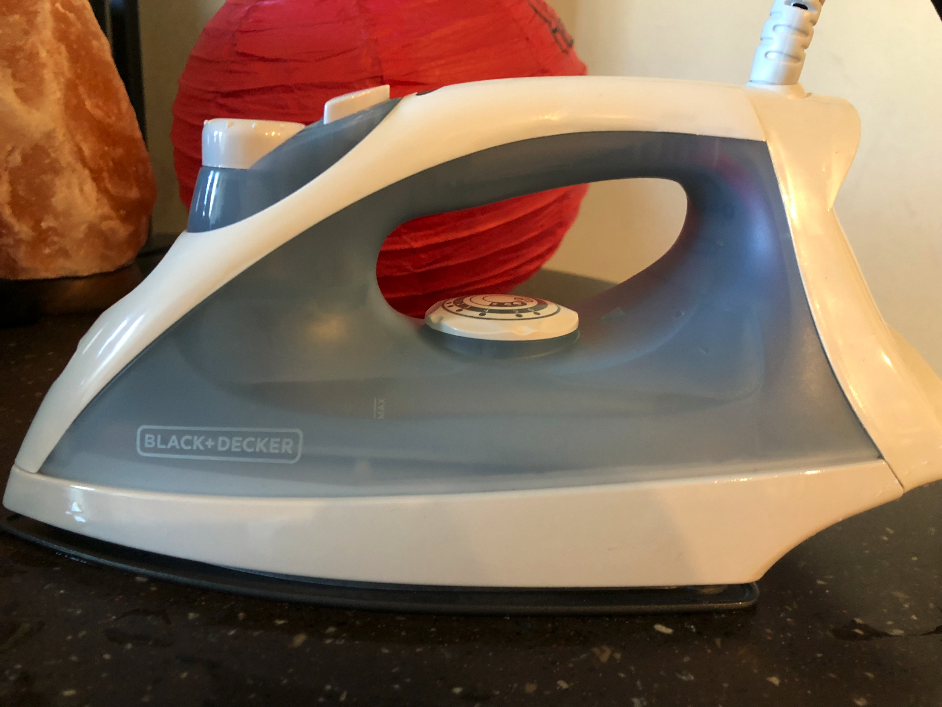

**Interview Methodology:**

We decided to interview the population at UCSD because we assumed that most students have ironed a piece of clothing at least once. Because an iron needs to be used in a particular environment, we ended up **convenience sampling** our friends and roommates because it was easier to have them show us how they would use the iron in their apartments with an environment with plug outlets, a water source, and enough space to iron the shirt. Even though we used convenience sampling, we did try to ask both females and males and have a range in age of our interviewees.

For our interviews we asked pre and post simulation questions. Most of our pre-simulation questions were questions to get a better understanding of the demographics of the people that we were interviewing, such as age, gender, and occupation, along with some asking about their basic understanding of irons and their initial thoughts on the iron, including what they thought some of the symbols on the iron meant, when the last time they ironed was, and what they thought the button on the top of the iron was for. We asked the questions about their initial thoughts because we wanted to see if just by looking at the iron and not physically using it as an iron, if a user could understand what the function of the symbols and buttons were, and if the **affordances** and **signifiers** were clear.

For the actual simulation of ironing, we used the **mentor/apprentice model** to watch how our interviewees would iron a shirt. We did not give them any instructions besides giving them an iron and asking them to iron a portion of the shirt for us, so that we could understand their ironing technique and their interaction with the iron. Pictures from an interview are seen below.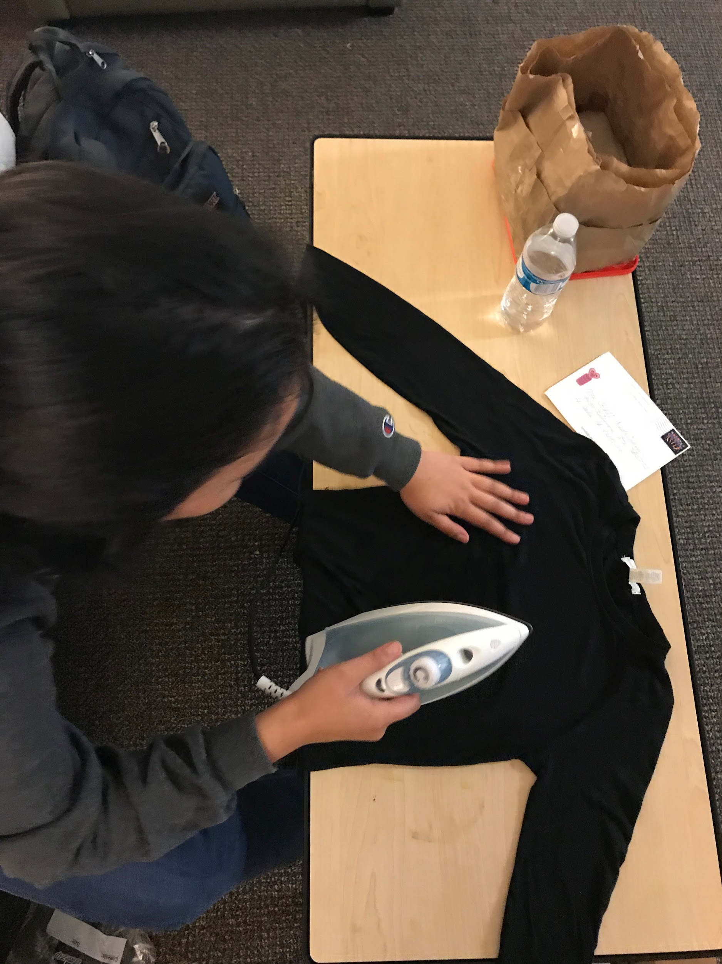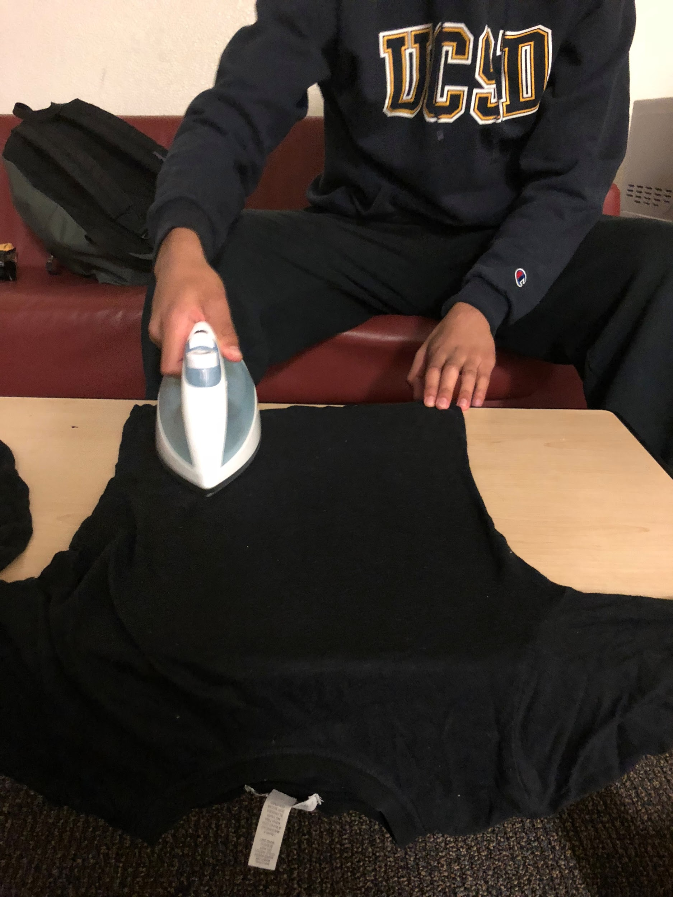

After our interviewees showed us how they used their iron, we asked them post-interview questions, such as asking if they noticed certain things that were difficult to find on the iron. An example of this included asking our interviewees if they noticed the max fill line because the location and placement of it was more obscure than other features, and we wanted to see if a casual user who wasn’t scouring the entire iron would be able to notice it. We also asked what they thought of certain features of the iron such as the blinking orange light, because the meaning color of the light could be interpreted differently based on one's cultural understanding of the color orange. More specifically, we found that some people think that orange signifies that the iron is ready for use, while others believe that the blinking orange signifies that the iron is heating up. Other questions asked were: what would they like to see improved on the iron, how they felt using it, and why they chose a specific hand orientation while changing the temperature settings of the iron. While we interviewed them we took notes on their actions and some verbal comments they made as they were using the iron. After the interview we put our observations and the answers to our pre and post-simulation questions into a [**Google Spreadsheet**](https://docs.google.com/spreadsheets/d/1P5t9HjRyBidTCUo6mLVASNSDaQz-uM5Ikpk165kU_l8/edit#gid=0).

**Problems, Trends, and Errors:**

*Problems:*

There were quite a lot of common problems that we saw when we did our interviews especially since our interviews followed the **mentor/apprentice model**. 44% of students expressed that the different dial functions were confusing so it took a while for them to figure out what they were doing as they ironed. Only 50% of the students we interviewed knew that the spray button sprayed water; 44% assumed it steamed the clothes, and 6% initially thought it was the on button for the iron. This is likely due to the symbol on the water spray button being similar in looks to the symbol on the steam dial which perplexed our interviewees.



There was also confusion with the steam and heat control dials due to the similar looking symbols which led students to assume that the spray button and the steam dial both controlled either steaming or spraying. However, some changed their answer that the dial and the button did the same thing because a **logical constraint** lead them to ask themselves the question of, “why would a designer would create 2 dials that did different things?”. Despite this, some people still did not correctly interpret the **designer’s conceptual model** of what the spray button and dial were for, and this may be due to people believing that the button and dial worked with each other to control steaming or spraying.

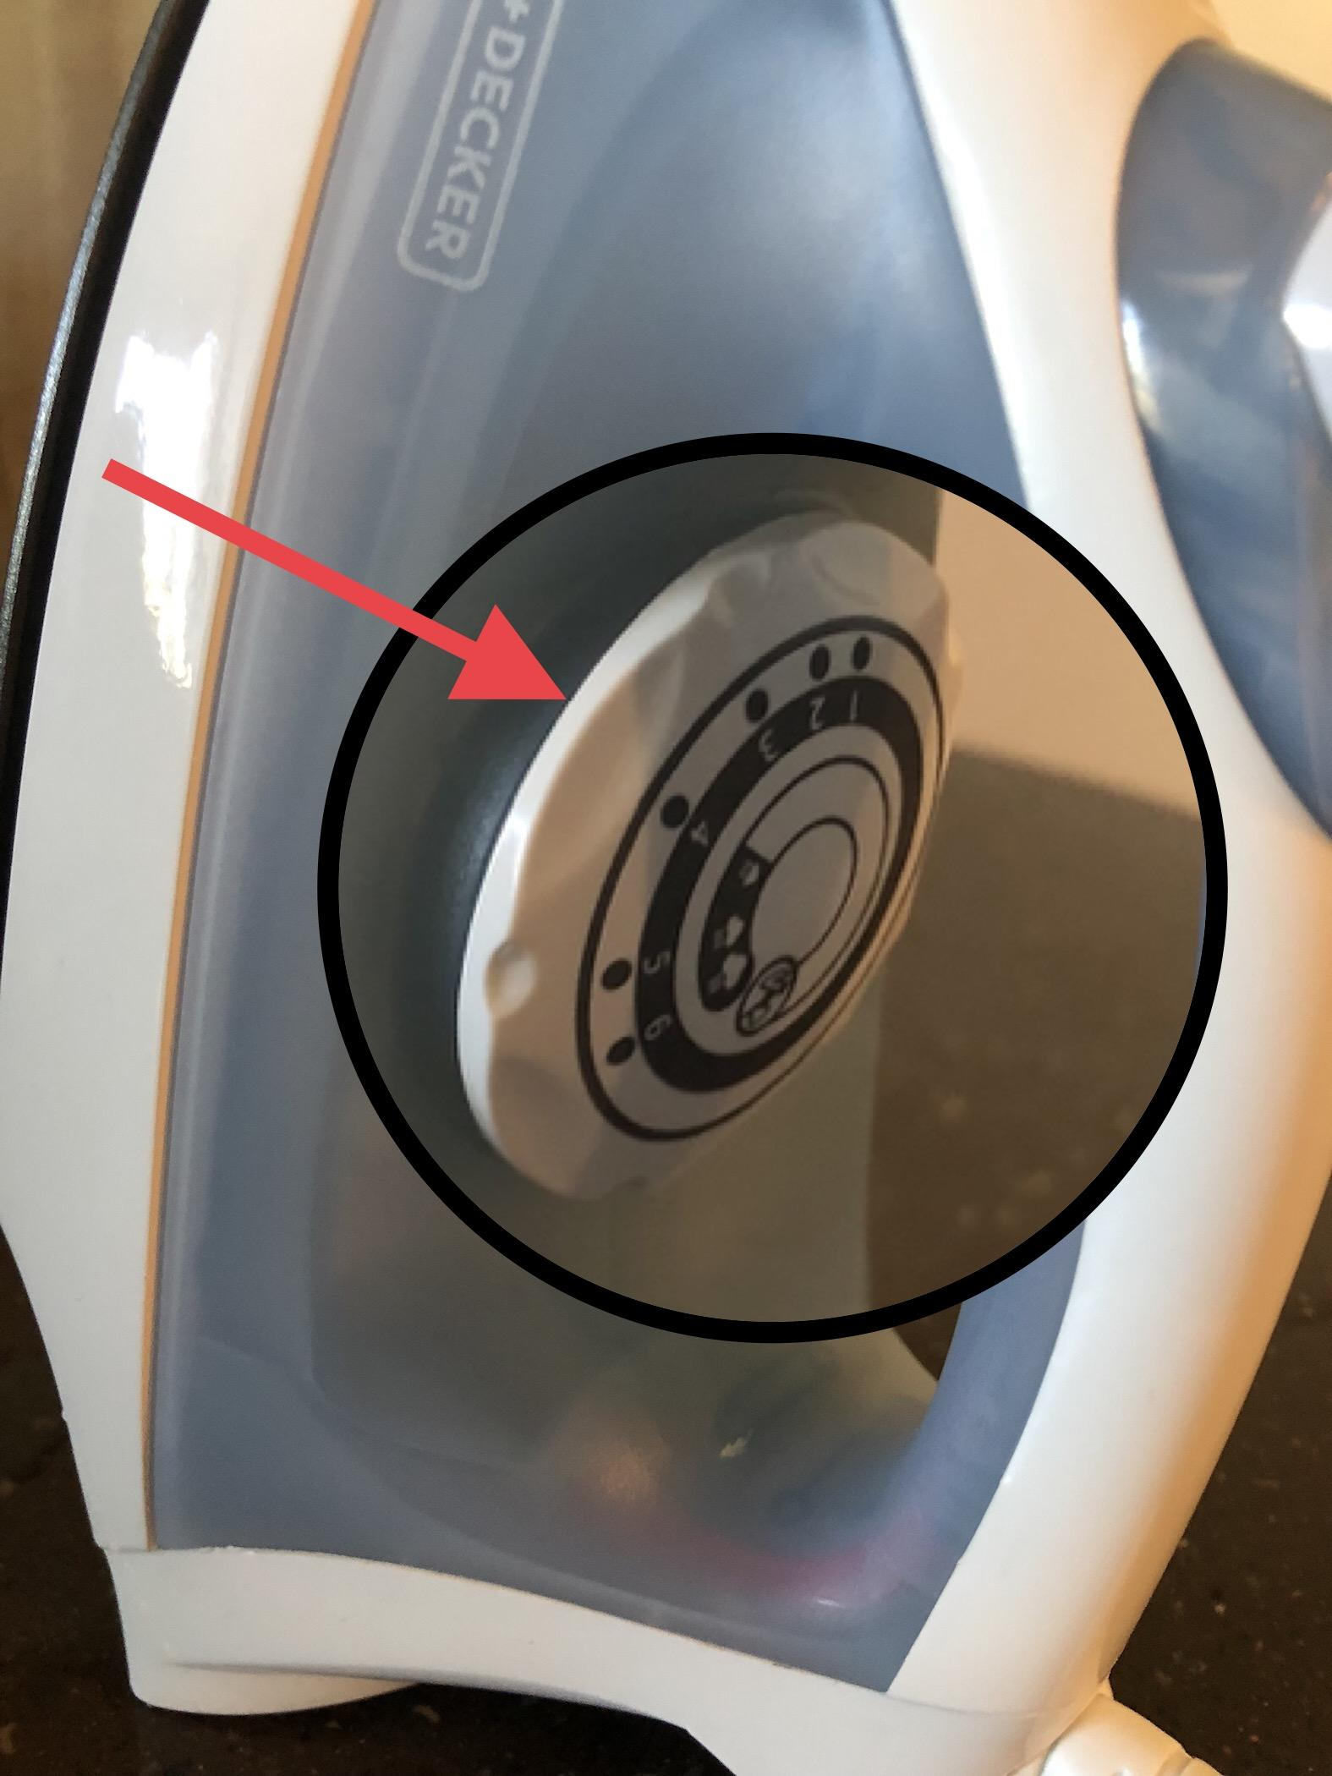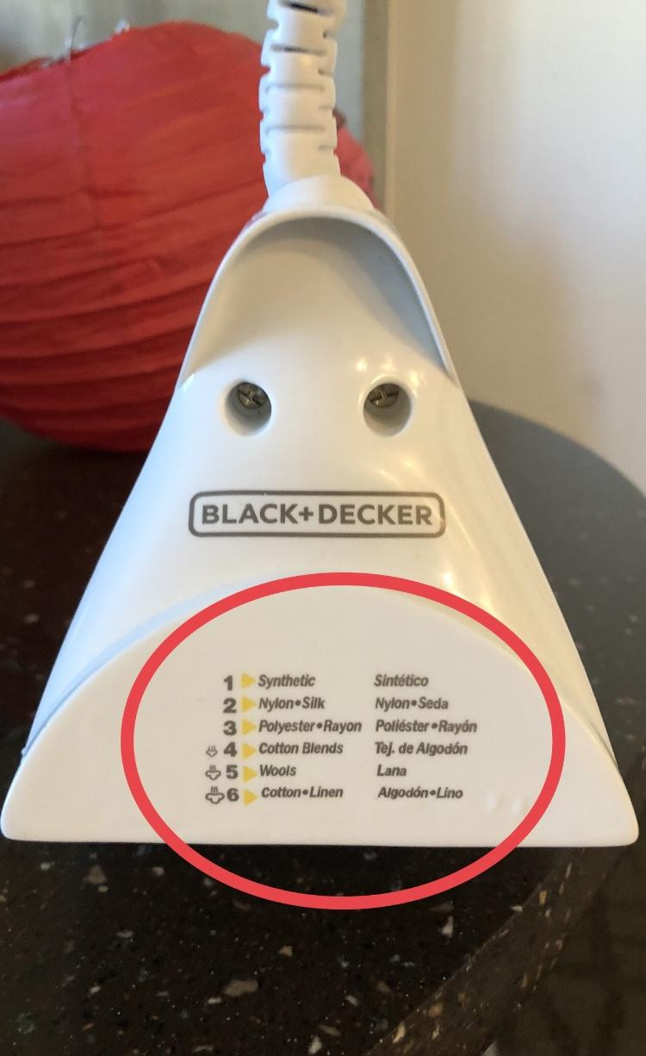

The numbers on the temperature control corresponded to the numbers written on the bottom of the iron which adjusted the heat based on the type of fabric the user was ironing.

In addition, people also had problems with knowing what the bigger dial on the base of the iron actually did. Only 50% had the right **mental model** that the bottom dial controlled the heat. Although, 27% did realize that the bottom dial connected to the numbers written on the underside of the iron some did not figure out that the numbers connected back to the temperature dial. The other 73% did not notice the heat settings on the bottom of the iron because there was no clear **signifier** of labels on the bottom. The bottom of the iron afforded standing so most people assumed that there would not be anything of significance on it. The bottom dial (temperature control) also did not clearly **afford** turning since it was under the handle and difficult to access. While it was clear that it had to be turned, doing so was expressed as “awkward” by 35% of the people we interviewed.

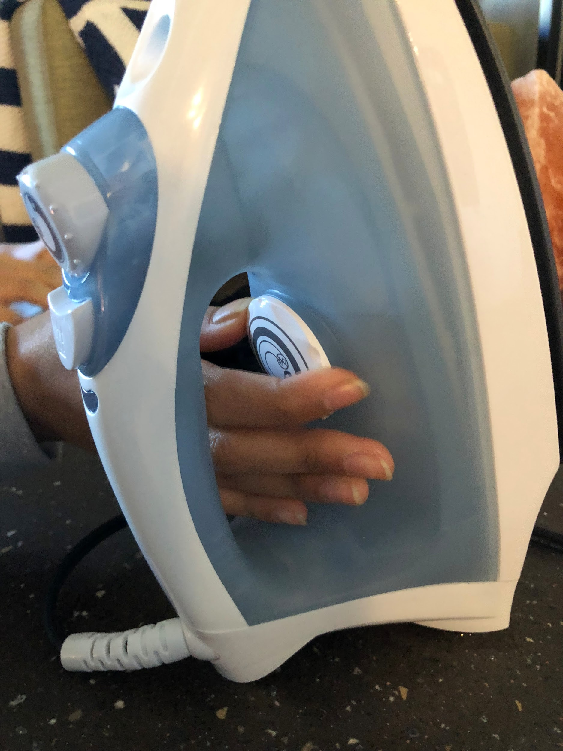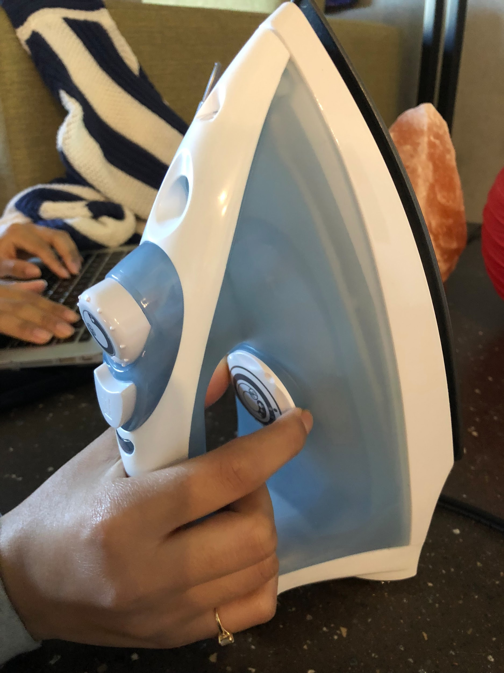

A problem people had was hand position of the temperature dial. 77% of those we interviewed did it from the side but mentioned the difficulty in doing so while the other 23% turned the dial over the handle as shown in the picture on the right.

There were also problems with filling up the water hole and 22% of the students wanted an improved version that made it easier to fill it up. 67% also did not notice the “max” line on the iron because of the small writing and the white font color which did not stand out against the barely transparent blue plastic.

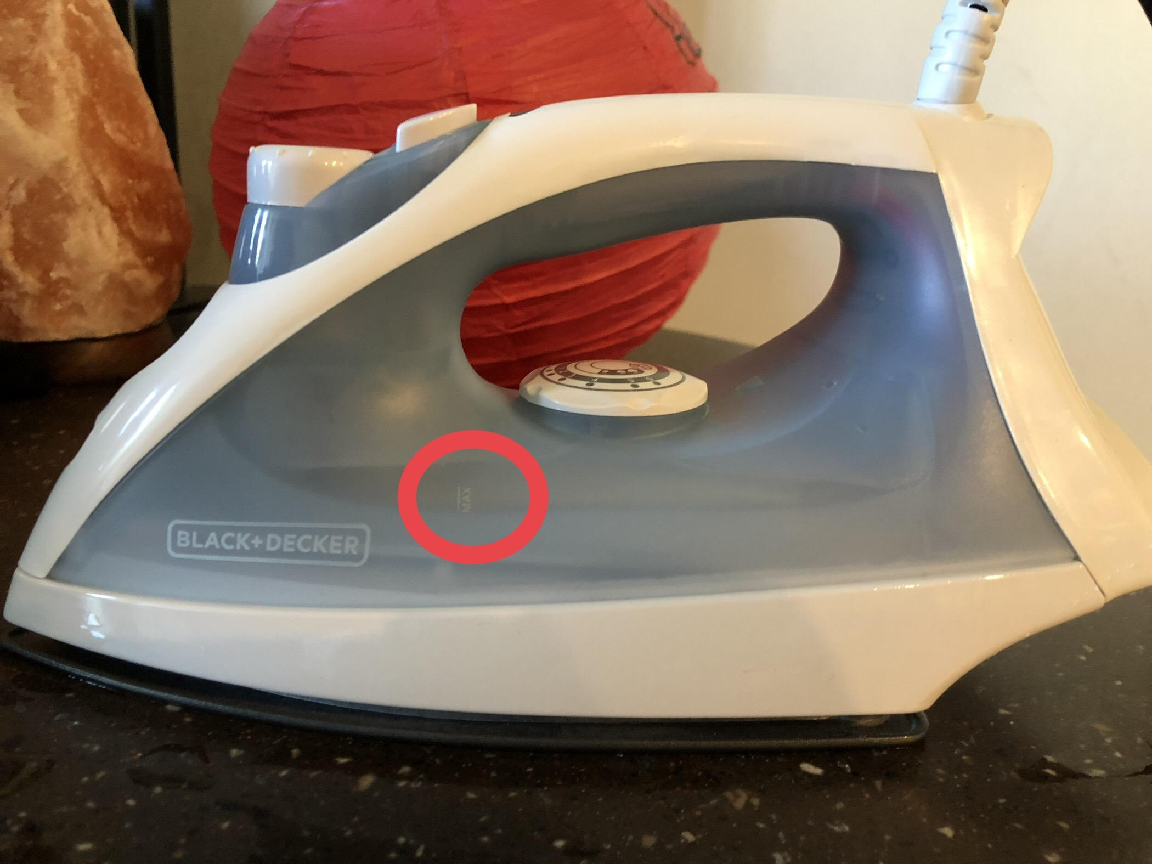

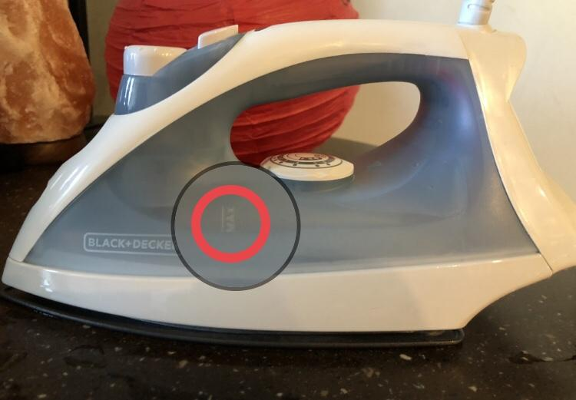

The top-most picture highlights where the “max” line is in relation to the rest of the iron. The font size is small and the font color blends into the blue background. The bottom picture shows a magnified version of the “MAX” fill line that was not so clearly signified on the iron.

There was also a lack of accurate **feedback** of the purpose of an orange blinking light and what it indicated. Some people thought it meant it was heating up, others thought it indicated that the iron was on but not being used, and and others thought it meant the iron plate was hot enough to start ironing. This confusing feedback confused our users more than helped.

*Trends:*

Some trends we observed throughout the interview process was that many college students do not iron their clothes. On average, the last time they ironed was at least a couple of years ago. There were a couple of people who do iron (everytime they do laundry) and also those who never ironed before. The majority of those who have ironed, ironed formal wear like dress shirts for either a business occasion or a formal party. Many expressed confusion about the top and bottom dial as mentioned previously. It took a while for them to look at both dials to see that they did not in fact have the same function. Only 27% of people looked at the bottom of the iron and noticed that the numbers on the big dial corresponded to the numbers written on the bottom (which indicated temperature level for different fabric types). 60% of those who looked at the bottom of iron only noticed the numbers as they were emptying out the water when they had already finished ironing towards the end of their interviews. We also noted that 50% of the students we interviewed had hurt themselves at least once with an iron. They commented that it happened when they were a kid or touched the iron plate. These accidents were most likely due to the user not knowing if the iron was hot or not.

[*Errors*](https://docs.google.com/spreadsheets/d/1P5t9HjRyBidTCUo6mLVASNSDaQz-uM5Ikpk165kU_l8/edit#gid=1934440679):

Throughout this we also examined different **errors** the students we interviewed made. There were a total of 10 different types of errors that were made 74 times overall. 30% of the errors were **slips**. Two of them were **action based** like when interviewees overfilled the water because they did not see the max line or using the incorrect heat setting because they assumed it was on the correct one. We counted not filling the iron with water as a **memory lapse slip** when the people we interviewed mentioned they have used irons before. All slips were done approximately 33% each. There was an almost even number of times people made these slips. There was a significantly less number of slips made compared to mistakes which is consistent since only a few of those we interviewed used irons on a regular basis.

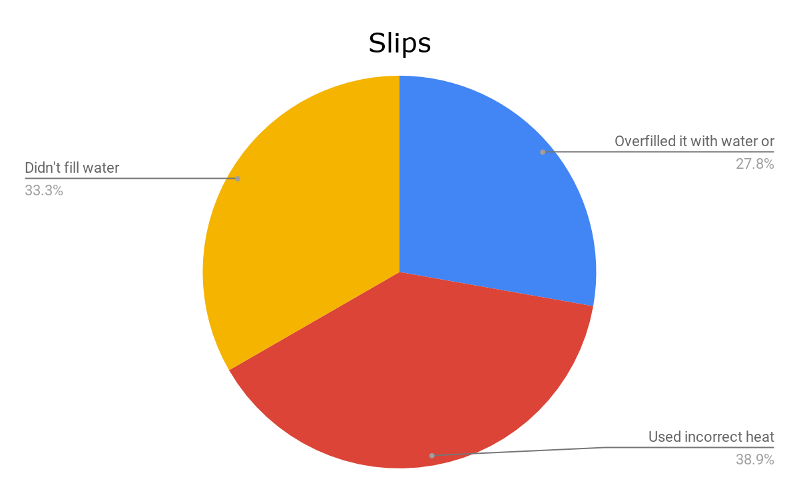

Of the 10 errors made, 70% of them were mistakes and occurred 56 times throughout all our interviews. 5/7 were **knowledge based mistakes** which consisted of not filling the water (because they did not know they were supposed to) or mistaking the top and bottom functions. The two biggest mistakes we observed was 77% of our interviewees not attempting to use the steam setting while ironing, and ironing when the light was orange. In our interviews, 87% of our interviewees had the correct mental model of what the orange light indicated: the iron is heating up. However, 56% people started ironing when the light was orange anyways. This shows the disconnect between the **user’s** and **designer’s mental model**.

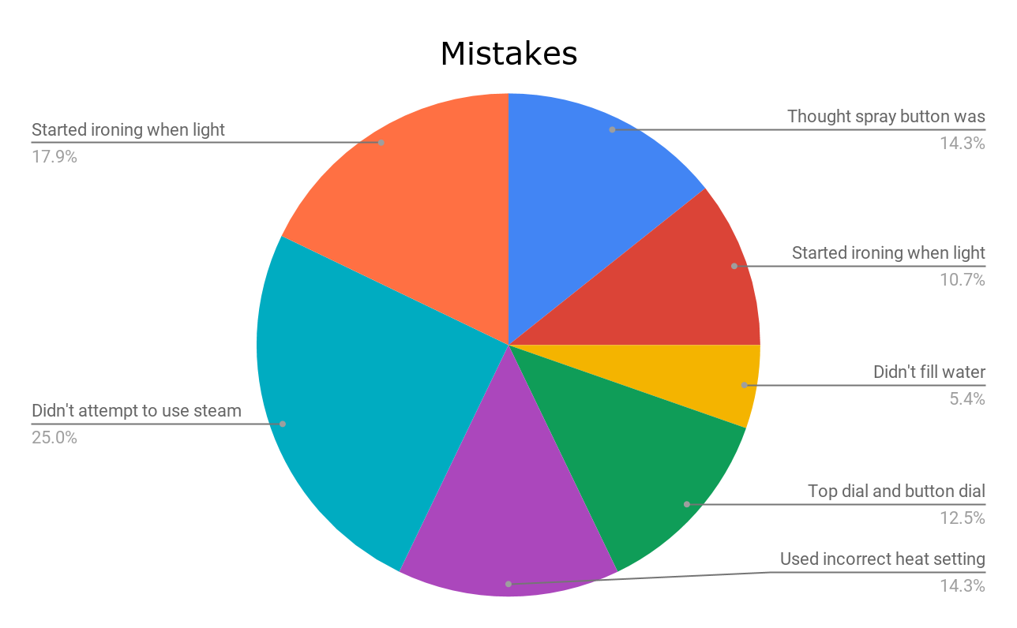

**Design Space:**



Our design space compares functionality and discoverability. Discoverability is on the x-axis while functionality is on the y-axis. We define discoverability as how well the iron **signifies** each of its functions. For example, we look at how easy and obvious it is to the user to decide which heat setting to set the iron to. For functionality, we examine how well each aspect of the iron works. For example, we look at an iron’s spray function and decide how evenly and effectively it sprays water onto the item of clothing. Particularly for functionality, we based the irons we didn’t have experience with off of Amazon customer reviews online. Each iron had around the same amount of online reviews, in the range of 442 to 472. Because the sample size of the amount of online reviews were large, we figured that this would help lower the amount of variance for the rating of functionality. We realize this may not be the best way to determine functionality for those irons, since each customer may have biases, but with our limited resources, we thought this would be the fairest way.

|  |  |  |  |  |  |
| --- | --- | --- | --- | --- | --- |
| **Brand** | Black & Decker | Sunbeam | Hamilton Beach | Panasonic | Oliso |
| **Image** | IMG-1139.jpeg |  |  |  |  |
| **Obvious Max Fill Line?** | no | yes | yes | yes | yes |
| **Obvious Water Fill Hole?** | no | yes | yes | yes | yes |
| **Distinct Spray vs. Steam Button?** | no | yes | yes | yes | yes |
| **Settings for Levels of Heat Clear?** | no | yes | yes | yes | yes |
| **Straightforward Light?** | no | yes | yes | yes | yes |
| **Amazon Rating** | n/a | 3.7/5 | 4.2/5 | 4.4/5 | 4.1/5 |

*Black and Decker Iron (our’s):*

* Discoverability: Directions for heat settings on bottom of iron, orange light is misleading, top dial’s purpose not obvious, water fill hole not obvious
* Functionality: Water leaks while ironing, water max fill line is perpendicular to the direction in which one would fill water, incorrect heat settings may be more commonly used with hidden directions

*Sunbeam Steam Master:*

* Discoverability: Different buttons clearly indicate what function they perform, water fill hole obvious, clear dials, clear color-changing light
* Functionality: Most reviews were positive; average rating was 3.7/5 stars with 470 reviews.

# *Hamilton Beach Steam Iron with 3-Way Auto Shutoff & Durathon Soleplate:*

* Discoverability: clear steam and spray buttons, digital heat settings corresponding to types of fabric, obvious water fill hole
* Functionality: most reviews were positive; average rating was 4.2/5 stars with 456 reviews

# *Panasonic NI-WL600 Cordless Multi-Directional Iron, Stainless Steel Soleplate:*

* Discoverability: obvious water fill hole, clear steam and spray buttons, clear adjustable steam release switch, clear heat setting button, apparent water max fill line
* Functionality: detachable water fill tank, average rating was 4.4/5 stars with 472 reviews

# *Oliso TG1050 Smart Iron with iTouch Technology, 1600 Watts:*

* Discoverability: obvious water fill hole, clear water max fill line, easy to use dial to adjust heat for type of fabric, clear spray and steam buttons, apparent switch for steam amount,
* Functionality: has “legs” that allows iron to hover without burning clothes that lowers with light touch and lifts when one stops ironing, average rating was 4.1/5 stars with 442 reviews

**Summary of Problems, Redesign, and Initial Prototype Ideas:**

In order to plan how we would redesign the Black & Decker iron that we had selected, we used the data that we had collected through interviews and error analysis to form the basis for the new features that our redesigned iron would possess.

*The Mysterious Orange Light:*

One of the first problems that our design team decided to tackle was the fact that with the current iron, users were not able to tell when the iron was actually hot without putting their hands dangerously close to the potentially scalding hot iron in order to check for heat. On the original design, when the iron was plugged in and a temperature was set on the iron’s dial, there was an orange light that acted as a **signifier** for when the iron was heating up. However, when the iron reached the desired temperature, the orange light would turn off and leave the user with no signifiers as to whether or not the iron was hot or not. This problem serves as a major safety hazard for users because there is a high potentiality for users to form the **mental model** that when the orange light is not on, the iron is not hot, and is therefore safe to touch when in reality it could be just as hot as when the orange light was on. This is also a problem that arises when the user is done ironing and unplugs the iron to put it away as the orange light does not function unless the iron is plugged into an electric outlet. 

In order to address this problem for the user, our redesigned iron will feature a light that changes into two different colors, red and green. The light will turn red to indicate that the iron is heating up or not ready to use. Specifically, this red light will help to bridge the **Gulf of Evaluation** for the user by giving them **visual** **feedback** telling them that the iron is actually heating up when they set the dial to their desired temperature while also saving users from actually touching the iron to know if it is actually working. The light will turn green and stay green in order to indicate that the iron has reached the desired temperature and is now ready to iron clothing. This green light will help users bridge the **Gulf of Execution** as it signifies to users when the iron has actually reached the correct temperature to allow them to iron their clothing. Both lights will stay on as long as the the iron is even remotely hot in order to signify to users that it is not safe to touch the iron yet. Furthermore, the iron shall feature internal battery just for the light so that even if the power cord is disconnected after use, the light will stay on in order to inform the user that the iron is still not safe to touch. This feature was implemented because throughout our interviews, 50% of interviewees reported that they had hurt themselves in the past while operating irons because they had no way of knowing when the iron was hot without actually putting their hands near the iron. One tradeoff between this light and the previous model’s light as a signifier is that it may be a bit more complicated for users as there will now be two different colored lights that they must be aware of instead of just one. However, we feel that this design iteration of the light increases discoverability as it will help users form a better mental model in terms of knowing when the iron is at a safe temperature to handle as opposed to blindly mishandling dangerously hot metal.



*The Confusing Temperature Settings:*

Another problem that our design team had to address when redesigning our iron was that users had a difficult time knowing what heat settings on the iron were appropriate for the type of fabric that they were attempting to iron. While conducting simulations of ironing with our Black & Decker iron, we found that many of the user were confused by the fact that the dials on iron itself seemed to feature arbitrary numbers as signifiers as to what temperature the dial would be setting the iron to. The numbers on the temperature dial correlated to hard to notice instructions on the bottom of the iron that listed the fabrics that each number represented. This **mapping**  of controls was definitely a problem for a majority of users because of the users that we interviewed, 66% of them did not even notice the instructions on the back of the iron until they were already dumping the water from the iron into the sink. Additionally, this form is poorly designed as the signifiers for what the controls do are placed in a position that does not allow the user to look at the dial controls and the mapping correlations at the same time.

In order to address these problems in our redesign, we decided that instead of having a confusing dial system to control the temperature of the iron with an awkward mapping scheme that was hard to see, we would instead use a slider placed on the side of the handle that controlled the temperature of the iron with the types of fabrics listed directly on the slider so that users can just slide to the type of fabric that they need ironed. This mapping would be much improved over the original design as the confusing number system would be done away with and the types of fabrics that the user would want to set the iron to would be located directly on the slider itself. This redesign would address the discoverability of the controls as now the temperatures correlate to the type of fabric being ironed and it would all be in one convenient area for the user to notice. This redesign would also improve the functionality of the iron as users would now be able to adjust the temperature more easily on the fly while using the iron because they can easily slide the to the desired temperature instead of finicking with an awkwardly placed dial below the handle. A picture of our redesigned slider that controls temperature can be seen below.

One alternative redesign that could be discussed, would be the location of the temperature settings, because some people may prefer the temperature settings to be in a different location such as the handle itself. In order to find out what location users prefer, more data collection and testing is needed. 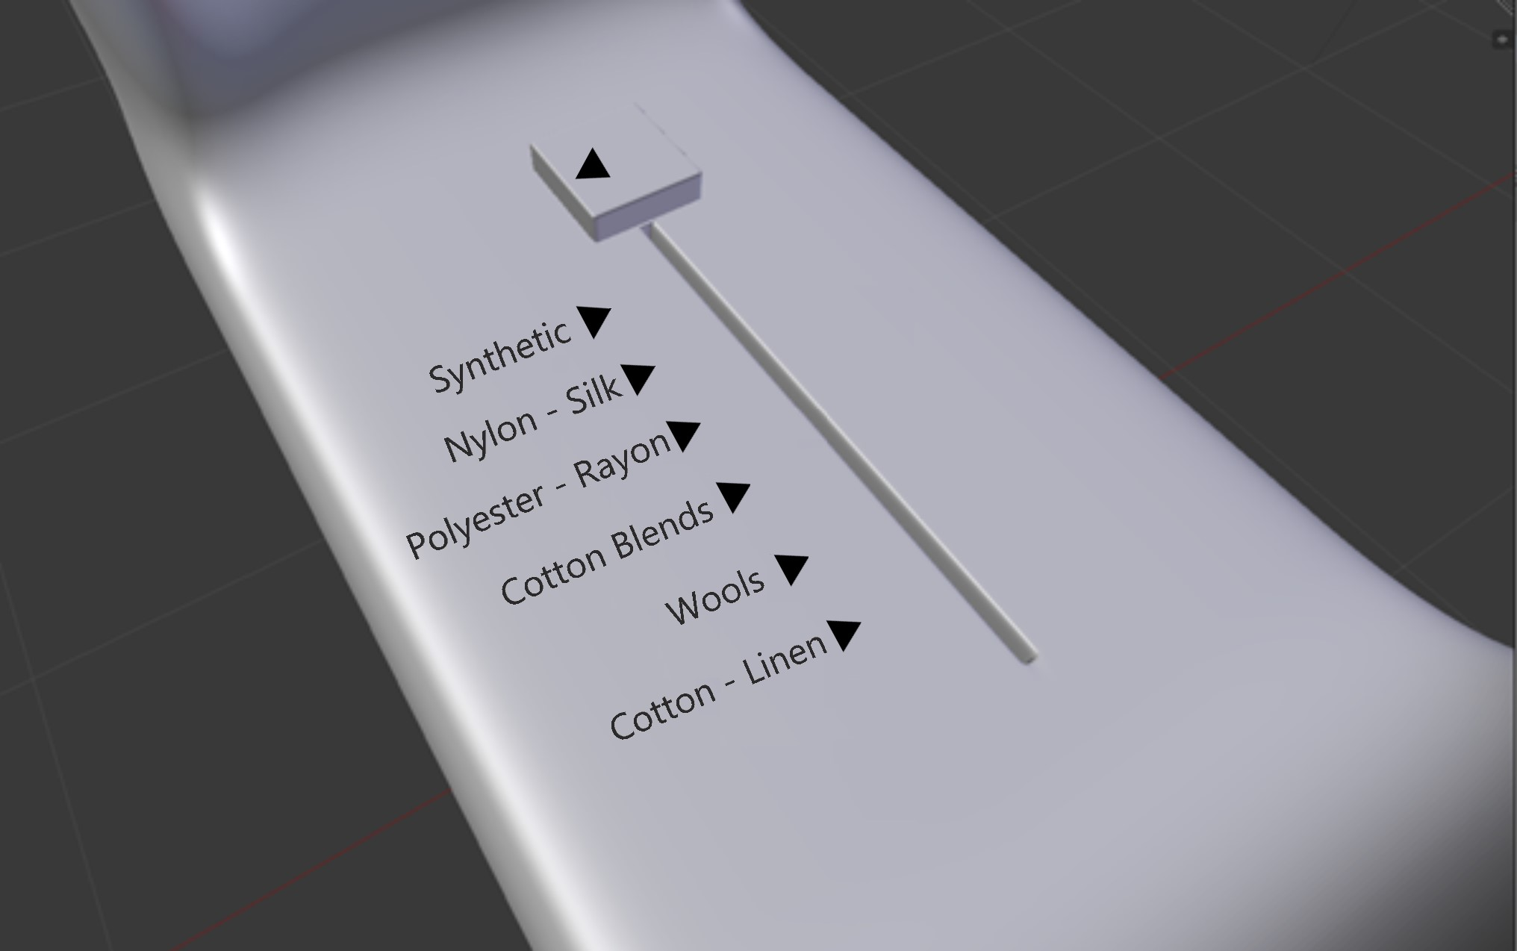

*The Steam and Spray Button:*

Furthermore, a problem we with many of our users was that they were unsure as to which the button featured on the iron was for steam or spray or if the dial next to the button worked in tandem with it. We found that 44% of users felt that the symbols on the button and the dial were too ambiguous and had no way of knowing what they really did until they actually started testing the button and the dial. The ambiguous **signifier** on the button may have been purposeful however because the button could release either steam or water based on the temperature set by the dial. However users found this configuration for steam and water to be confusing and unnecessary because if they wanted steam and the dial was set to spray, they would have to move the dial to the desired steam setting and then wait for the iron to heat up before it could release steam. 

In order to solve this design problem, our team felt that we should do away with the dial for setting temperature entirely and instead just have two buttons instead: one for steam and one for spray. The buttons would have clear symbols on them to signify that one was for steam and one was for spray so that users would not be confused as to what button does what. To indicate steam, a symbol of clouds will be used, and on the actual button, it will say “steam”.

To indicate spraying water, a symbol of water spraying will be used, and on the actual button it will say “spray”.

An example of what these symbols would look like are below.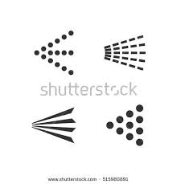

STEAM SPRAY

The above symbols would be on the buttons on the sample prototype below.

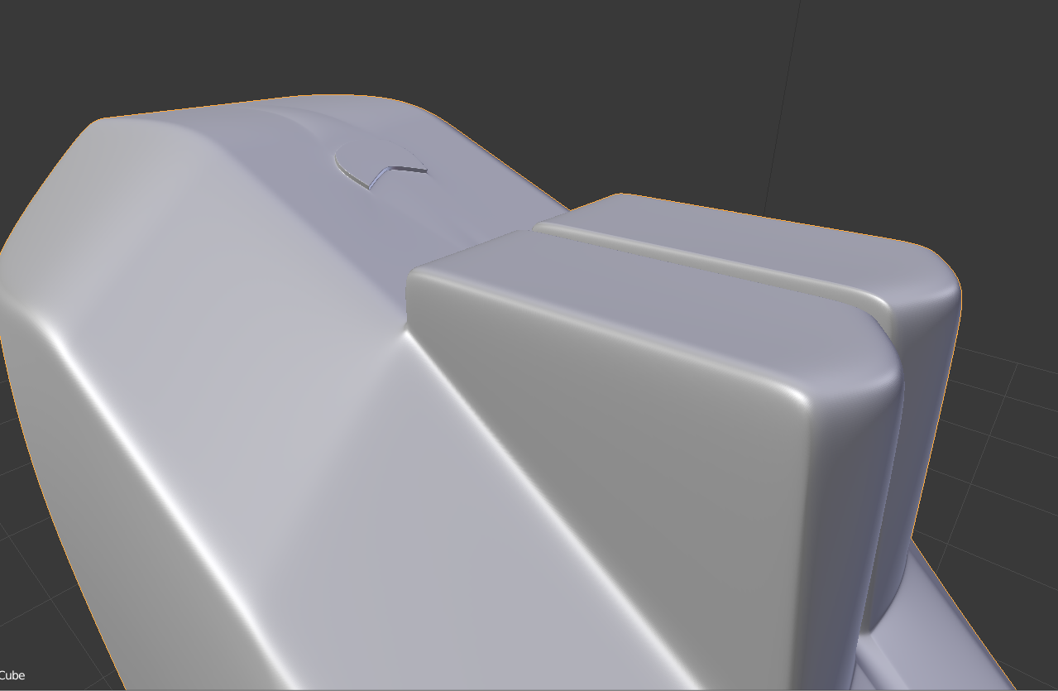

If given more time and more interviewee data on whether or not people prefer to be able control the amount of steam than an iron releases, we could alternatively come up with a dial that controls the amount of steam, and a button to control when steam would be released to combat this tradeoff.

*The Irritating Small Water Hole:*

The final problem that our design team tackled within our redesign was the fact that users were having trouble putting the correct amount of water within the iron when they were filling it up before even plugging it in. On the Black & Decker iron, the fill hole was small and angled so it only **afforded** filling up with a very small stream of water while holding the iron in an awkward slanted position while filling it up. 22% of the users saw the iron stated they wanted an improved filling hole. With the old design of the filling hole, it was easy to watery mess if the stream of water was too powerful or the iron was not held under the sink a the correct angle. Furthermore, the max fill line that users would use in order to gauge the amount of water that they were putting into the iron was oriented so that users could only check if the water was adequately filled if the iron was held vertically under the sink. As most users would fill up the iron horizontally, this posed a problem because the fill line did not afford users the ability to see how much water was in the iron as they were filling it up. The max fill line itself was hard to see as 67% of users did not even see the line because it was the same color as the semi-translucent clear plastic that contained the water in the iron. Another problem that arose during testing was that since there was no cover for the hole, often times when users were handling the iron vigorously, water would leak out through the hole and make a mess.

Our design team’s solution to this problem was to filling hole that was not angled and larger so that more water could enter the hole at once. We also created a small cover for the hole so that users would be able to close it once they were done filling up the iron with water and not have to worry about any of the water leaking out. An example of what this would look like can be seen in the prototype below. The blue semi-translucent water container on the iron was not very functional so we would like to change the color of the plastic to be clear and translucent so that the water could be more easily seen. Additionally, we changed the max fill line to be black, bigger, and oriented horizontally so that users would be able to read the line while they were actually filling it up instead of having to flip the iron vertically. These changes would increase both the functionality and the discoverability of the iron as now users could more easily fill the iron with water and would have a much easier time learning when the iron was adequately filled. 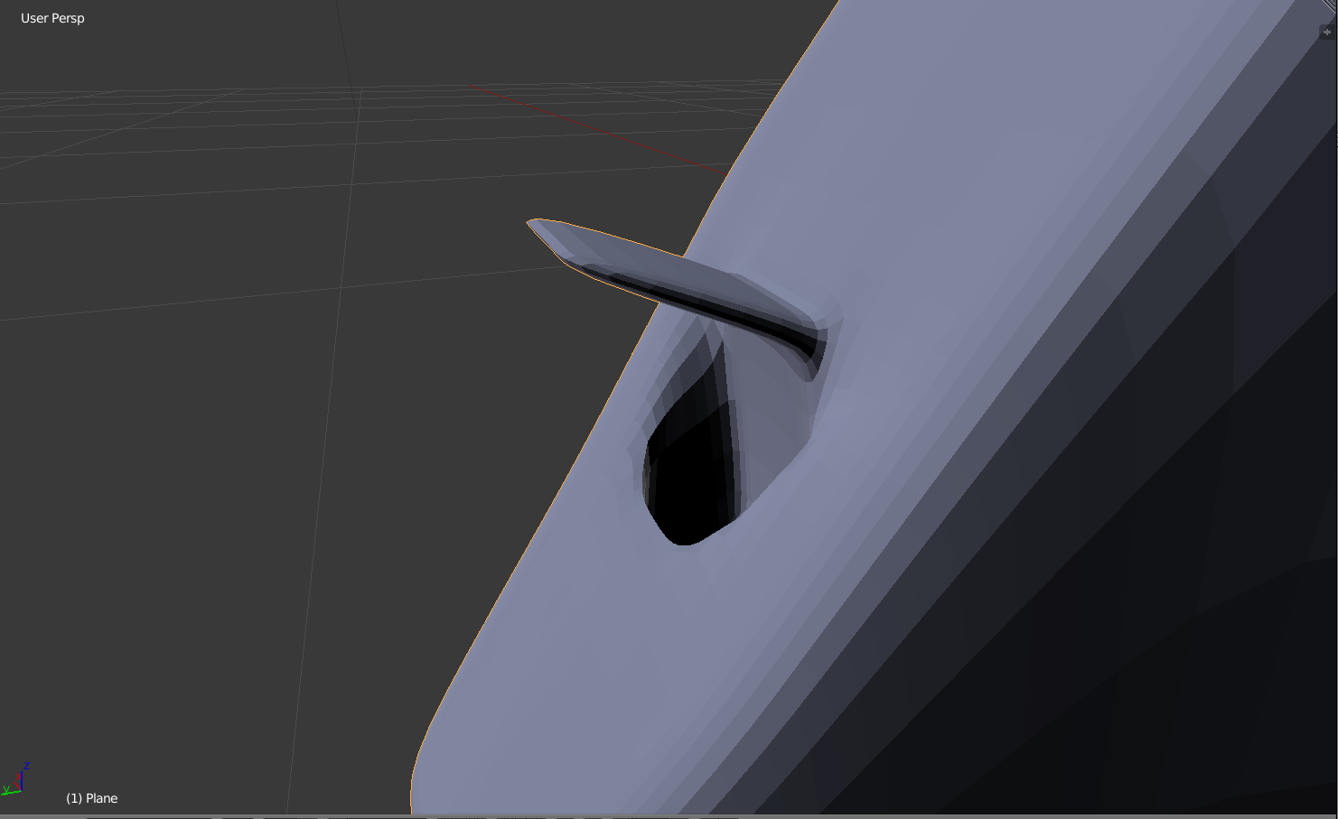

All in all, in terms of our design space, we find that our new changes to the iron lies in the ideal quadrant of maximum functionality and discoverability as we have overhauled or done away with all of the problems that made ironing an overly confusing or taxing activity and added features that would help make the ironing process more straightforward and easy. Our redesigned iron lies in the complete opposite quadrant of the design space from the original design that had low discoverability and functionality. Ultimately we feel that this redesign will appeal to users who are sick and tired of fussing with irons that are poorly designed and want to just iron their clothing in a quick and easy manner.

**Conclusion and Moving Forward:**

All in all, after following the **Double Diamond Design Process,** we were able to **discover** the existing problems that existed within the current design of the iron through interviews and product testing, **define** the most important problems that needed to be addressed through error analysis, **develop** different iterations of the design that would help to solve these problems, and ultimately picked the best iteration in order to **deliver** the best prototype possible for our new iron design. By combining the different perspectives of our diverse design team and working under a common **point of view** for how we wanted the iron to look, we were able to solve existing design problems we found within the Black & Decker iron and create a design that accounted for these problems as a first priority.

The next step for our newly designed iteration of the household iron is to create a high fidelity prototype and have actual users test it so that we can see if there are any problems with the current iteration of the iron that we had not foreseen. If any problems arise, during user testing and data collection, we will take user feedback and error analysis into consideration and bring the design back through the double diamond design process. We will continue to iterate on the design until we have the best possible iteration of our iron design. When we feel we have reached a design iteration that we are satisfied with, we will begin mass production of the iron and attempt to bring it into the commercial market, so that users can actually purchase the iron that we designed and experience the hard work and effort that went into trying to make ironing as an activity much less taxing and time-consuming. We hope that through our efforts, we will be able to make a significant impact on the lives of users everytime they use the iron that we designed.